Class diagram:



Package Diagram:



DB Diagram:

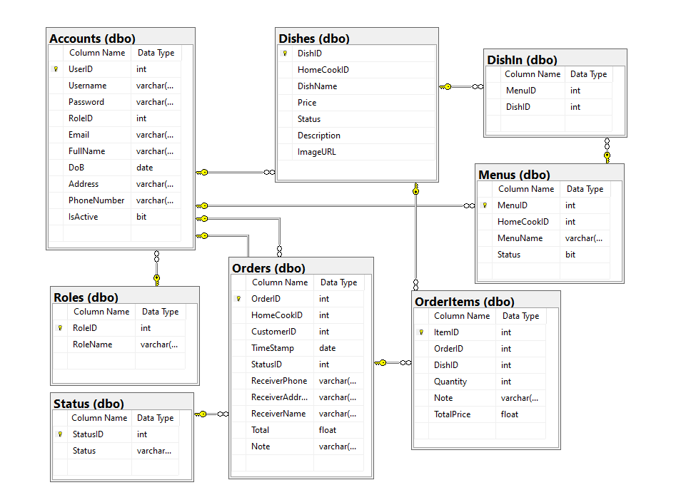

ERD:

